Merchandise Forecasting Planning

Response to:

REQUEST
FOR
PROPOSAL

Provided by



September 8th, 2003

Table of Contents

LVC Required Response Format 3

Respondent’s Executive Summary

Solution Summary

Product/ Solution Functionality Description

Top-Line Business Objectives Solution Requirements

Solution Support

Implementation and Team

Implementation Schedule

Investment / Pricing

Company Overview

References / Qualifications

Miscellaneous

Open-Ended

Merchandise Planning and Execution Process Overview 23

- LVC Required Response Format
  - Respondent’s Executive Summary

Please include in this section a general overview of your understanding of our needs, the solution, benefits and differentiators.

  - Solution Summary

As Lillian Vernon strives to meet customers’ changing needs and preferences while contributing the greatest profits to the business across all selling channels, you are faced with increasingly complex challenges in today’s business environment such as a consumer driven economy leading to greater product proliferation, multi-channel retailing in a difficult economic climate.

Today’s marketplace dynamics demand innovative strategies. Evant’s Retail Management software offers solutions to the retail industry’s most complex problems. With a powerful combination of software, science and technology, Evant enables its customers to free up significant amounts of working capital by decreasing inventory, increasing service levels and improving merchandise performance. Uniquely blending art and science, Evant enables its customers to quickly respond to changes in consumer behavior and react to market opportunity – an advantage that creates improved margins on the bottom line.

Undeniably, retailers will continue to tackle demand chains that are both complex and perpetually evolving. Those companies that employ sophisticated technology tool that enable them to leverage “best practice” business operations will ensure that they have the right products, in the right quantities, that the right place at the right time – the right formula for continued growth and profitability.

As Lillian Vernon works to achieve its goal of becoming a $1 billion leading multi-channel retailer known for superior products, values, customer experience, operations and profitability, Evant offers the optimal solution to assist in obtaining this objective.

Evant’s Retail Management solutions will provide Lillian Vernon with:

- The first multi-channel retail planning solution that enables cross-channel and channel-specific merchandising
- A replenishment solution that drives optimal inventory considering multiple channels through an easy to use tool that drives planner productivity and profitability
- The first enterprise information management system that provides a centralized system of record repository for retail enterprise data that drives reporting
- The only enterprise software for the retail industry built on a scalable J2EE platform

Based upon Evant’s understanding of Lillian Vernon’s business requirements, the Evant Retail Management solution set will address the business and functional needs. The Evant Retail Management suite is made up of three workflow components: Evant Merchandising, Evant Planning, and Evant Enterprise Information Management which are integrated to your current systems infrastructure.

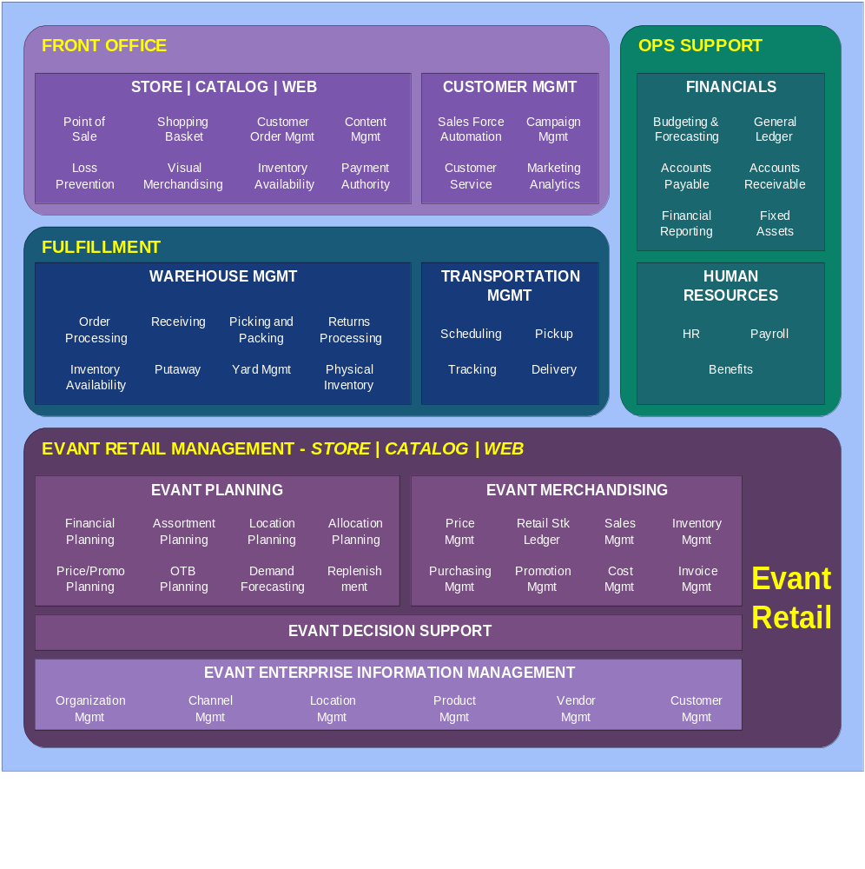

To enable the workflows depicted above, Evant provides a suite of software modules which can be installed in various phases and components to provide maximum value and return on investment for Lillian Vernon. The software components include:

    - Evant Merchandise Planning (MP) & Demand Planning & Replenishment (DPR) – two distinct modules utilized for planning and forecasting. (Both proposed for LVC)
    - Evant Enterprise Information Management (EIM) – infrastructure base for all vendor, product, location and channel management. (Proposed for LVC)
    - Evant Decision Support – data models for catalog, web, and product inventory and selling data. Evant implements our proprietary data models into Lillian Vernon’s decision support tool (i.e. – microstrategy, oracle express, etc.) (Proposed for LVC)
    - Evant Merchandising – transaction management, inclusive of purchasing, pricing, inventory management. (Not being proposed as part of this project)

It is important to understand that functional pieces of each module will be combined in a phased approach to ensure that the implementation of the Evant solution meets the most critical needs of Lillian Vernon first, followed in succession by the addition of other functionality to further augment the solution.
Given our understanding of your business objectives we would recommend the following implementation roll out.
  - EIM (Enterprise Information Management) – Inclusive of SKU conversion and product setup functions. The EIM module is leveraged in all other modules (offer setup, catalog & assortment planning, and replenishment/purchasing). Initially during project scope, all base elements of the product and offer master databases are identified and documented for module setup. Daily job workflow is integrated into the alerts module based on industry best practices or Lillian Vernon’s current process flow.
  - Conversion of historical demand and other transaction based data – Merchandise Planning, Purchasing and Decision Support rely on actual information converted form legacy systems. The conversion process can occur at the same time as the EIM module implementation.
  - Decision Support – Beginning with data conversion of at least two year’s actual data, the decision support module can be leveraged to perform analysis of prior offer drops and SKU performance. With the EIM infrastructure in place, the data model conversion can begin leveraging product and offer hierarchy relationships.
  - Catalog and Assortment setup and planning – Transition catalog setup (product to book relationship) from legacy systems into Evant’s application. Begin the process of planning by offer/drop followed by the assortment plan across seasons using Merchandise Planning ( MP).
  - Purchasing/Replenishment – When the user community becomes confident in the planning process, begin exporting receipt and sales plans into the purchasing and replenishment module of Evant (DPR). At this point, purchases will be generated from the assortment plan based on planned response rate % or forecasted catalog % complete measures.

Interface points into Warehouse Management, Customer Order Management and Financial systems are provided via XML feeds for product, vendor, transaction (sales, demand, customer and vendor returns, purchase order receipts, and inventory adjustments), and purchase order data.
Note: Please refer to the LVC diagram at the end of this document for specific functionality coverage to Lillian Vernon stated requirements.

The Evant Retail Management Suite is architected on an robust infrastructure designed to be highly scalable and easily integrated to existing systems. The open platform is 100% J2EE compliant, database independent, and was designed using a web serviced architecture. It is browser based with no plug-ins or applets.

Application Architecture Overview

Note: - Application is also available running Oracle 8.1.7 or better

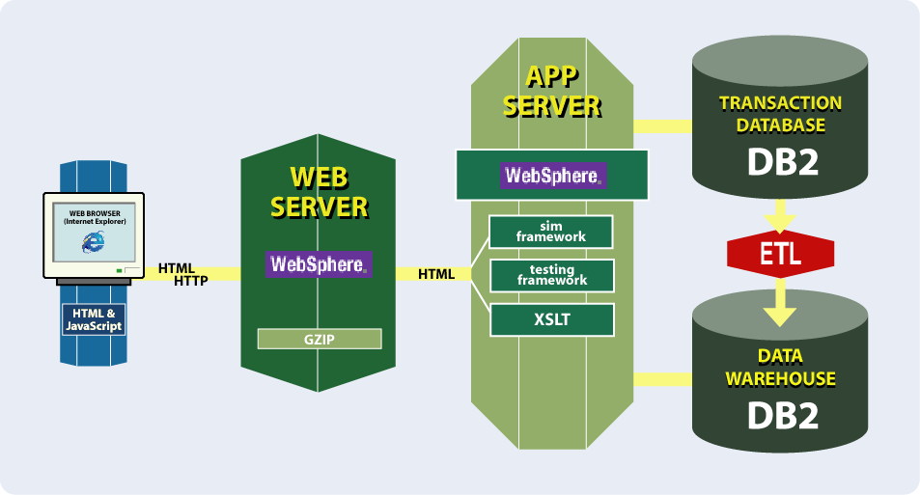

Evant’s user interface is web-based, utilizing Microsoft’s Internet Explorer Version 6.0 or better. The user navigates through the application using the browser, mouse and keyboard. Within the Evant application suite, drop down windows, task bar icons, column and row rotation techniques are leveraged. The application itself is Java based, rendering screen images via XSLT and HTML protocols. No additional requirements such as plug-ins, or applets are established on the user’s workstation. Evant recommends 256 MB of memory on the desktop for loading the HTML pages requested by the user.

Technical requirements

- 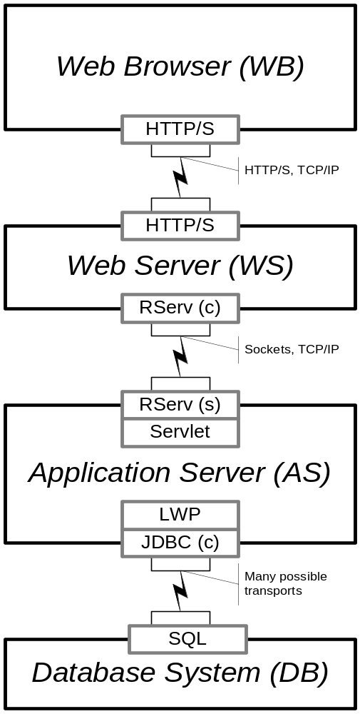Web Browser Requirements
  - HTML, CSS, DHTML, Javascript
- Web Browser Deployment
  - Template based
  - Currently IE 6.0 or better
- Inter-Tier Communication
  - Uses standard transports and interfaces
    - HTTP, TCP/IP,JDBC

- Web Server Requirements
  - Standard Capabilities, Servlet, Zipping
- Deployment Options
  - Apache, Weblogic, WebSphere
- Inter-Tier Communication
  - Websphere Inter Change Server (ICS)

- Application Server Requirements
  - Java 1.3+, J2EE support for JDBC, Servlets
- Application Server Deployment
  - Platform Standard Java, WebSphere,
Weblogic
- Inter-Tier Communication
  - Transports are efficient for both distributed
& Single machine configurations

- Database System Deployment Options
  - SQL, LOBs, JDBC support,
  - Good memory management
  - Oracle 8i+, DB2
- Inter-Tier Communication
  - WS/AS responsibility to support RServ

The Evant solutions and technologies are designed to provide measurable business improvements to customers, including increasing sales and customer service levels, increasing working capital, increasing inventory turns and dramatically improving planner productivity.

Note that all training and pricing information will be covered in later sections =NOTE THE ACTUAL SECTIONS

C. Product/ Solution Functionality Description

The Solution
Evant offers the first multi-channel merchandise planning, demand forecasting and merchandise replenishment application designed to support retailers. Evant’s comprehensive solution supports the complete range of merchandising-related processes including planning, replenishment, forecasting, merchandise transaction management and operational analytics. Evant’s application is built with best-in-class Web-based technologies including Java and XML. The Evant solution is based on open standards, delivered over the Internet through a web browser and follows a multi-tier architecture. Evant’s underlying architecture is scalable and built to handle the transactions volumes and number of users necessary to be successful in the retail environment.

Enterprise Information Management (EIM)
Evant's Enterprise Information Management (EIM) tool provides a 'one-stop' location through which users can monitor and manage all product information critical to the daily operation of their business. Product information may be tracked across multiple business channels, including web, direct/catalog, point of sales and fulfillment systems. Users may customize information captured based on an unlimited number of user-defined product attributes, such as color, size, personalization, seasonality, or product dimensions. The EIM application also provides a mass update capability, allowing for quick management of information on groups of products.

Merchandise Planning Module (MP)
The Merchandise Planning System offers powerful multi-channel inventory planning and forecasting capabilities that can help increase margins, improve turns, and increase sales.

Evant’s software can plan and forecast sales and inventory requirements across multiple category levels, stores, catalogs, and time periods, all the way down to the SKU level. Forecasts can be developed using sales history, demand response rate curves or other projections. When sales order and shipment information is available, forecasts can easily be revised, allowing merchants to take best advantage of unexpected hot sellers while minimizing exposure due to under performing products.

Evant provides a rich set of pre-defined templates to enable merchants and inventory planners to quickly implement a planning solution. The templates offer the user flexibility in configuration by selecting from 5 best practice inventory calculations and planning by units, retail or cost. These best practices workflows quickly enable world class planning process to be integrated into an organization such as Lillian Vernon. Measure names, display values and symbols, as well as view orientation can also be configured based on user preferences. The templates support tops down, bottoms up and middle out planning, as well as Pre Season and In Season planning processes fully integrated into a single plan view. The template highlights are:

Merchandise Financial Planning
Supports tops down planning process
Focused on Demand/Sales, Turn and Gross Margin
Plan in Retail or Cost, derive Units for reconciliation to Assortment plan

Assortment Planning
Supports bottoms up planning process
Focused on Demand Units and Purchase Order flow
Plan in Units and/or Retail, derive other by Average Units Retail (AUR)

Catalog Financial Planning
Supports Multi-Offer Seasonal tops down planning process
Focused on Offer Profitability, Sales, Cost
Plan by Response Rate, Average Order Volume or # of Orders

Catalog Assortment Planning
Supports Product/Offer bottoms up planning process
Focused on Product Demand, Inventory Position and % Complete
Plan by Demand Units or Product Response Rate

Key Item/Assortment Planning
Supports Product/Store Cluster bottoms up planning process
Focused on Demand Units and Receipt flow
Plan in Units derive retail using Multiple Average Retails

Demand Planning & Replenishment Module (DPR)
Evant’s Replenishment and Forecasting module is an advanced demand planning and inventory replenishment solution that addresses the complex challenges of managing demand variability, supply variability, customer service level expectations, and inventory requirements. The suite is designed to maximize business value by optimizing forecasting and replenishment processes at the distribution center and/or store level.
Multiple Safety Stock Strategies to Manage Inventory and Service Goals
The application offers four replenishment strategies for calculating safety-stock levels and meeting target service levels. The first is a standard service percentage goal. The next three use the power of optimization and simulation: 1) for a given safety stock investment, minimize the lost sales in dollars, 2) for a given safety stock investment, minimize the number of shortage occurrences, and 3) for a given safety stock investment, minimize the line “cuts” (unfilled items that keep an entire order from shipping). With our system, service level targets and different safety stock strategies can be readily applied at the SKU (item/location) level, with the help of mass-maintenance tools. You can use this to assign higher goals to critical or fast-moving products and lower goals to your slow-movers. Once you choose your strategy and target, you can review the expected impact before actual implementation. This gives you the maximum return on your safety-stock investment—resulting in lower safety stock, higher inventory turns, and improved in-stock positions.
Advanced Statistical Forecasting that Delivers Superior Results
Evant’s robust and proven forecasting approach takes care of outliers, and accounts for trend, seasonality, and day-of-week factors. The methodologies used for demand cleansing, trend estimation, and seasonal profiling are proprietary and yield better forecasts than standard approaches. Evant’s approach is focused on three distinct areas:

Adaptive algorithms for updating forecasts. The application applies forecast error measure and adaptive/dynamic smoothing. Using a proprietary method for recalculating and adjusting the ‘alpha’ factor, our system applies heuristics built into the forecasting algorithm to update the forecast for the next period. The result is a more accurate forecast, less safety stock, reduced inventory investment, and greater buyer/analyst productivity due to fewer exceptions.
Comprehensive demand management. The application’s forecasting capabilities address all types of SKUs including basic staple items, promotional demand, new products, slow movers, and short life cycle products. For example, Evant customer, DOT Foods uses our system to more accurately forecast its short-shelf life products (perishables such as dairy and yogurt)—resulting in a 25% reduction in product obsolescence.
Advanced seasonal profiling. Evant has developed an automated process, based on unique science, for determining seasonal profiles. Highly efficient algorithms are used to cleanse historical demand data, extract measures of trend and seasonality, determine appropriate seasonal profiles for all SKUs, and establish an optimal cluster of core profiles. The end result is a manageable, actionable set of core seasonal profiles that enhance the accuracy of short and long-term demand forecasts--reducing forecast error and resulting in lower inventory investment without a negative impact on in-stock performance.

Superior Distribution Management that Gets the Right Product to the Right Place
The application provides extensive capabilities for transfer orders, factoring in all relevant financial factors (such as transportation costs, inventory costs, handling costs) before recommending a transfer order—so that transfers between locations are made only when economically advantageous. Customers like O’Reilly Automotive, provide local stores with access to a much broader range of products on a same day delivery basis (for example, transferring from nearby stores with more product selection and stock, rather than from the distribution center). Evant also provides unique allocation logic (e.g., for constrained supply), as well as extensive return recommendations capabilities.

Grouping EOQs Leverages Vendor Discounts
The economic order quantity (EOQ) grouping leads to enhanced margins. It provides item-based optimization and the subsequent grouping of EOQs together to meet vendor discount offers, leading to buy-side margin improvement. The application enhances this concept by balancing ALL vendor items still to be ordered, not just those that are due to be ordered today, to achieve available discounts.

More Profitable Investment Buying
The application offers superior, completely integrated replenishment and deal buying functionality, for forward buys, ASV buys, and speculative buying. Suggested orders address both normal replenishment requirements as well as deal buying opportunities, and are integrated into the buyer’s daily workflow. Our system also provides advanced investment and alternate source buying capabilities, including flexible controls to set objectives and add extra days of inventory at the SKU level versus only at the system level. For wholesale distributors across all industries as well as retailers engaged in deal-buying at the DC level, this functionality can become a significant competitive differentiator.

Efficiently Managing Inventory for Complex Distribution Networks
The complexities in inventory management multiply when there are multiple echelons in a hierarchical structure. The Replenishment and Forecasting multi-echelon capabilities ensure that forecasting, planning, and ordering occur at multiple levels in a synchronous fashion, providing optimal inventory and customer service levels at the enterprise level. Without enterprise-level optimization, changes at one level result in magnified reactions at the next, generating a ”bullwhip” effect—by the time the “real information” reaches the top level, it is already too late and the result is overstocks or outages. With our multi-echelon capabilities, changes in seasonal or promotion information at a lower echelon are automatically passed upward. A Distribution Requirements Planning (DRP) model does not adequately address this problem as there is no linkage between echelon safety stocks, making inventory and service optimization impossible.

Transforming Data into Business Intelligence
Evant’s application provides extensive what-if analysis and simulation capabilities for replenishment planning, as well as unlimited SKU grouping capabilities for ordering and reporting, safety stock and service level targeting. All fields in the system are available for reporting, providing you with more accessible and actionable information for decision-making. The system also provides very detailed inventory stratification/segmentation, with up to 27 data layers to differentiate between replenishment inventory, safety stock, promotional, forward buying and other levels of inventory at the SKU-level for each warehouse or store. Furthermore, the suite provides enhanced graphical and historical analytical views, with powerful and highly flexible decision-making tools for determining which SKUs to keep in stock, identifying forecasting anomalies, resolving overstock situations or analyzing suppliers’ order-to-delivery performance.

Alerts Management
Managing change is important in the dynamic world of multi-channel retailing. To help companies cope with unpredictable events that might require immediate attention - and better monitor routine performance indicators - Evant's application suite is equipped to deliver automated business alerts, based on sets of user-defined exception criteria. Whenever information meets the criteria, the associated module will send users an alert notifying them of important events that can potentially impact business performance. Alerts are delivered via Evant's Workbench, a personalized gateway to each module of the Evant solution. Designed as a fully customizable homepage, the Workbench enables user-defined access to a variety of tools, information and value-added E-services. The advanced alerts capabilities form a natural business process workflow for users. It turns each day into one of management by exception and proactive planning from one of traditional reaction. This step-by-step approach to planning generates an environment focused on profitability for the business and not just feasibility of the plans.

Security Levels
Experience with customers in a variety of industries has allowed us to imbed extensive security provisions to fit any situation: by group, by user, by menu, function, and option navigation. At the file and field level, access is monitored for update or view restrictions. Evant’s application suite can use these capabilities to conform to most security requirements.

The Benefits
A sample of actual Evant customer benefits is below. Similar results would be expected for Lillian Vernon.

- Reduced inventory investment by 20 to 50 percent
  - Increased inventory turns by more than 40 percent
  - Freed up $100+ million in working capital

- Improved service levels by up to 10 percentage points
  - Increased sales and maximized in-stock performance

- Increased buy-side profit by more than 100 percent

- Improved buyer productivity by up to 100 percent

YEILDINGINCREASED PROFITABILITY AND IMPROVED RETURN ON ASSETS

Evant Process Flows
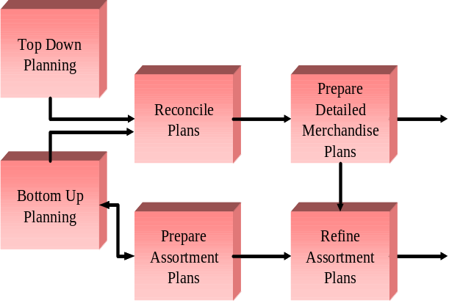
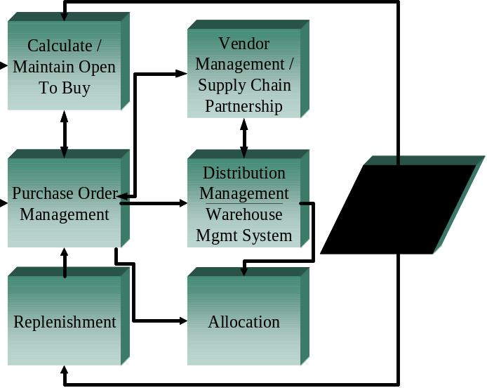

Evant’s Response to Business and Technical Requirements
This section is an overview of how Evant would meet Lillian Vernon’s specific solution requirements. The sections and format follows the same as the original RFP.

Top-Line Business Strategy and Planning

Evant provides a data model inclusive of five star schema’s for decision support activities. These models, offer, purchase order, sales and inventory, planning and web, are implemented by Evant’s technical team to handle performance history analysis as well as plan vs. actual comparisons. Our selector tool functionality allows our client’s to monitor activity against 1500+ key performance measures.

Merchandising Plans, Goals, and Objectives

Merchandise plans can be created at any level of the merchandise hierarchy. Our hierarchy is n-tiered, allowing for as many levels as required to run Lillian Vernon’s business. The original or pre-season plan is locked and used to manage and track plan vs. actual performance, at the offer level. Multiple offers can be planned within the same template, allowing for a full seasonal view. When in-season, the forecast version of the plan is developed utilizing catalog % complete to original plan, reforcasting need based on the original budget. As forecasts are modified, the new receipt and demand flow can be used to update purchase order quantities and timelines.

Merchandise and Assortment Planning

Assortment plans are developed by week by SKU leveraging over 380 key performanace measures. Five versions of the plan are available inclusive of OP (original), FC (forecast), WI (what-if), PM (previous forecast), TY and LY (actuals). As sales and transactional data post in-season, the users can develop and change forecasts based on actual to plan performance. Plan rules are used to trigger alerts against these plans to monitor, plan vs. actual percent variance for sales, receipts, or inventory values. Other rules may include Weeks of Supply or Gross Margin targets. Each night, the plan rules are reviewed and triggered, allowing the user to react to only those areas where action is necessary. Assortment to financial planning reconciliation takes place, where the user can identify which plan is in control. The increase or decrease from assortment to financial is prorated to the other based on percent to total contribution of the existing plan.

Demand Forecasting – Inventory Planning and Optimization

Evant uses proprietary mathematics and science within our demand forecast and optimization engines. A team of scientists continually improve our application to provide sophisticated forecasting and modeling techniques within the DPR module. The economic order quantity (EOQ) grouping leads to enhanced margins. It provides item-based optimization and the subsequent grouping of EOQs together to meet vendor discount offers, leading to buy-side margin improvement. The application enhances this concept by balancing ALL vendor items still to be ordered, not just those that are due to be ordered today, to achieve available discounts.

Purchasing and Purchase Order Management

Evant offers a suggest purchase order quantity that can be transferred to legacy applications. Assortment plans are used to generate promotional or planned demand within the DPR module that are later used to create suggested orders for identified product. Deals and vendor discounts as well as product lead times can be accounted for in the purchase order process. Product sample tracking and status is monitored within the EIM toolset.

Vendor Relationship Management

Evant does not currently support Vendor Relationship Management processing within our current or near term footprint. Vendor Relationship Management tools and tracking processes are usually housed within a warehouse management application.

Business Performance Reporting

Evant provides a data model covering catalog, web, plan, purchase, and sales & inventory flow data. Over 1500 pre-defined measures are covered within the five star schema models for use in a decision support tool. Lillian Vernon must decide on a decision support product and Evant will provide professional services to incorporate our data model into the selected tool (i.e. have experience with microstrategy and oracle express).

Product Information Database (Product Library)

Evant's Enterprise Information Management (EIM) tool provides a 'one-stop' location through which users can monitor and manage all product information critical to the daily operation of their business. Product information may be tracked across multiple business channels, including web, direct/catalog, point of sales and fulfillment systems. Users may customize information captured based on an unlimited number of user-defined product attributes, such as color, size, seasonality, or product dimensions. The EIM application also provides a mass update capability, allowing for quick management of information on groups of products.

Technical Requirements Overview

Evant’s solution set is based on an open architecture as required by Lillian Vernon. All application code is java based, leveraging a web-based model. We are truly a web-based vs. web-enabled application, utilizing a web browser, web server, application and database server model. No additional software is required on the user’s desktop to run Evant applications. Messaging can be accomplished using FTP, MQ, or TCP/IP protocols. DB2 or Oracle are fully supported in the application set. All API’s are XML based, in its simplest form, comma delimited or flat file interfaces are used to pass data in and out of the application. The planning application also includes an export function, developing plan data by week by offer by product for use in other applications (decision support or replenishment) as required by Lillian Vernon.

  - Top-line Business Objectives Solution

Vendor should detail how they are able to supply and support:

    - Development of the following:
- Review of performance history
- Translation of top-line goals to actionable targets
- Alignment of goals and plans across business units
- Integration of business objectives with Merchandising Business Unit targets

In addition, please describe the Reporting tools and systems that will enable the reporting requirements listed above

  - Solution Support

Warranty Information
Evant represents and warrants that the Software will materially perform to the Specifications for a period of ninety (90) days after the delivery date, and that the Services provided will be performed in a professional and workmanlike manner.

Service Response Levels (Customer Support)
Problems are considered an Emergency when there is complete system failure, high impact data integrity issues and no workarounds are available. The initial response from the support representative will occur with in one (1) hour of notification.
Problems are High priority when the system is down or unusable, purchasing orders cannot be generated, the nightly batch job cannot continue running, or the software is otherwise severely impacted. The initial response from the support representative will occur with in two (2) hours of notification. The status of the problem will be updated at least two (2) times per day until the problem is resolved.
Problems are Medium priority when the system is working and there is a work-around for the issue encountered or some other degradation in the performance of the Software is perceivable by a user of the Software. The initial response from the support representative will occur within four (4) hours of notification. The status of the problem will be updated every two (2) business days until the problem is resolved.
Problems are Low priority when there is a cosmetic issue with the system, when a functionality question or clarification requested, or when a malfunction of the Software is limited to back-end processes or data exchange and not perceived by the user of a Software. The initial response from the support representative will occur within one (1) business day after notification. The status of the problem updated with the release notes or plan for next release.

Evant’s focus is to provide superior customer service and additional customer commitments include:
- Access to Customer Support Portal (24/7 access to submit new issues, and knowledge base to check on status of open issues)
- Enhancement Request process to manage requests for additional future functionality – Measured in terms of initial turnaround on response, and status of response (Disposition status: Next release, next voting list, or a custom modification)
- Professional Services Semi-Annual Survey (measures performance of consultants, performance of Customer Support, performance of Education and Documentation)

Evant utilizes a Customer Support model consisting of telephone support Monday-Friday 7am-7pm eastern standard time and web-based access to Customer Support personnel twenty four hours a day, 7 days a week. Cases are assigned a priority based upon the parameters defined above for emergency, high medium and low.
Customer Support Representatives are tracked against the following metrics:
  - Number of Cases Opened
  - Number of Cases Closed
  - Number of Cases Opened and Closed by Age
  - Number of Cases Opened and Closed by Priority
  - Average Number of Cases per Week
  - Average Number of Cases per Day

As a customer, you will have access to Evant’s Customer Support Portal, a web-based interface that allows you to submit a new issue to Evant at any time, day or night, as well as track the status of any open cases that you may have previously submitted. You will also have direct contact information for your Customer Support Representative and Evant’s Customer Support Management team.

Given the metrics and case management procedures described above, should an issue need to be escalated, Evant ensure that the process is designed to reach all levels of executive management if necessary.
Issues are reported to the customer support analyst, then escalated to the Customer Support Manager, then to the Vice President of Professional Services, then to the President of Evant, then to the CEO.

- Version release schedules, if known
- Support for third party vendor solutions, if any are proposed
- Reporting capabilities – present options, tools, etc.

Training
Evant curriculum provides more than just solution training. Evant courses help students become comfortable and confident with the solutions, enabling them to perform profitably. Competency and achievement are established by participating in the appropriate Evant certification program.
For each product there are courses that comprise the required standard curriculum for Level I certification. These courses are recommended for all individuals who will be using the system. Additional courses and levels of certification augment the standard curriculum.
All courses are developed by the Evant Education Department staff, including instructional designers, training developers, technical writers, and content experts. Evant designs and develops courses that provide information users need to drive the highest return on your investment.
Evant employs educational consultants with years of experience in their field. These consultants are always available for onsite education on specific functions or more advanced product features.
In addition to the Evant curriculum, each product is supported by a comprehensive online information system that contains step-by-step procedures, field definitions, a glossary of terms, and principles of operation.

The process for determing a specific training plan for Lillian Vernon would include:
- Identify the timeline for knowledge transfer, training curriculum and other factors that reflect how you will ensure knowledge transfer is/has occurred.
- Early Implementation: A discovery and analysis session is held at the beginning of the implementation process. The purpose of this session is to understand the audience to be trained, including their skill and knowledge levels; to determine if there any unique training requirements; and to determine if any of our standard courses need to be modified or augmented.
- Project Team Training: The customer Project Team members are given our standard curriculum courses prior to the start of the conference room pilot.
- Prior to Go Live: All those who will use our system(s) are given the introductory and basic courses that are part of our standard curriculum. The first part of Level I Certification will be administered to ensure comprehension before users are on the system.

Evant employs a blended learning approach that includes web seminars, self-paced web-based training, and instructor-led training.
- Courses that primarily teach concepts are delivered via eLive Learning. These are web casts that allow live primary instruction including presentations, application sharing, question and answers, and feedback. These web casts are recorded and available for playback.
- Courses that teach principles and hands-on procedures are delivered via self-paced web-based eAnytime training. This WBT is dynamic and employs animation, voiceover narration, on-screen simulation and built-in feedback.
- Educational consultants can deliver customized onsite instructor-led training for more as needed and arranged by the customer.

- Ongoing training support for new employees or new software releases
- Support team organization structure, duties and employee counts. Please indicate where resources are shared and applicable coverage metrics

INSERT INFO FROM CHIRAG HERE
Evant’s commitment to customers is characterized by allocating over 1/3 of its total workforce to Professional Services, and making companies wildly successful with their implementation of Evant solutions. You will interact with many resources both during and after the Evant implementation. All of these resources have measurements attached to their performance.

The Professional Services Organization is made up of the following roles:
  - Customer Support Representatives
  - Professional Services Consultants
  - Customer Advocacy
  - Consulting Services Practices Manager
  - Education & Documentation
  - Product Management Resources
  - Development Resources
  - Quality Assurance Resources

Customer Support Representatives - 6 Customer Support Analysts, 1 Customer Support Manager, reporting to the Vice President of Professional Services. Support Analysts are responsible for case entry, tracking, testing, diagnosis, reporting, and answering questions regarding system functionality. They also coordinate the sending of upgrades and patches, and answer limited questions regarding database setup as it relates to the product. Resources in Customer Support are not shared with any other department on an on going basis.

Professional Services Consultants – Consultants will be assigned to the Lillian Vernon project to not only help you implement the software, but to help you determine how to return your business to profitability and grow it to the $1 billion organization you aspire it to be. Evant consultants come with years of industry experience, many having done the very job of the people that they are working with at client sites. They understand the business problems and challenges retailers are faced with and offer not only expertise about Evant solutions but how to solve complex retailing challenges. They will help you to create a process and procedures to meet your needs.

Customer Advocacy—Your long term account manager—Assigned to assist you after your company is in production with Evant’s solution, your Customer Advocate will be a primary conduit of communication between your company and Evant. New product release information, new announcements, open forums on industry trends and impacts on your business, etc are driven by this role. The Customer Advocate is not measured on how much additional money you spend with Evant—the role is measured on Customer Satisfaction, your willingness to be a reference for other Evant prospects, and keeping your implementation at current software release levels.

Consulting Services Practice Manager—You will have the opportunity to brainstorm ideas and current implementation considerations with a Practice Manager that knows both the Evant solution set as well as the impact the solution provides to your business. This role is designed for someone with field level implementation and practical experience. Measurements for this role include amount of interaction time with customers, customer satisfaction, and ability to increase your return on investment in Evant solutions through the use of offerings such as System Performance Assessments.

Education and Documentation—The development of our education and documentation materials is done by a team of professional educators (in lieu of implementation consultants that try to do training). Our instructors are measured on depth of knowledge of the material, ability to communicate effectively and efficiently, and overall customer satisfaction. The curriculum and materials are also measured through customer surveys in order to assess the quality of the material.

Access To Executive Management—Evant has an open style of communication throughout the organization, and you will have the opportunity to interact with the executive management team to provide input, feedback, and develop a “trusted advisor” from our management team that can assist you and your business in areas such as long term planning, new industry trends and the business impacts these trends will have, contacts in other Evant customers, access to the analyst community, etc.

With the help of Evant and our Professional Services Organization you will be able to achieve the following:

- You will consistently be able to drive measurable results through implementation of best practice processes based on deep domain knowledge of Evant consultants. Many of the consultants that will be engaged on your project were former buyers and planners, having firsthand experience at living in the finished goods purchasing and planning world.

- Your Evant consultants become “trusted advisors” to you—many “how to” and “why” and “what is the impact” questions are answered on an on-going basis by the Evant consulting team.

- Your planners and buyers will have the opportunity to participate in curriculum developed by Evant’s Education and Documentation group—education that is both application-specific, as well as business-specific knowledge, which will help your buyers and planners grow to become true analysts and strategic contributors to the business. Since turnover of your personnel can be expensive and time consuming, the documentation delivered (both on-line as well as hard copy) will be invaluable to training and ensuring on-going consistent processes within your company.

- As an Evant customer, you can help drive the future direction of the solution roadmap….the product feature set is directly driven by an enhancement request process that evaluates your requests and input based on strategic direction of the request.

- Customer Support. You will benefit from the investment in Customer Support that Evant has made—in both people and processes—to allow 24 x 7 case creation and case status information. Trained personnel that get to know your implementation, your business and map that to providing solutions to software issues with a sense of urgency.

- Accountability. Evant has a heart for service in every customer interaction—Customer Support, Consulting, Education & Documentation, Customer Advocacy, and access to anyone in the Evant organization that can help customers be successful.

  - Implementation and Team

Evant’s Implementation Methodology Overview

There are three tightly integrated phases that make up the Evant implementation methodology. These phases are referred to as Scope, Design/Develop, and Integrate/Implement. An additional phase called Production Support covers ongoing operations such as implementation support and planning and executing upgrades. An overview of each phase is provided below followed by details of activities that fall within or cross phases.

The following picture is an overview of the entire methodology:

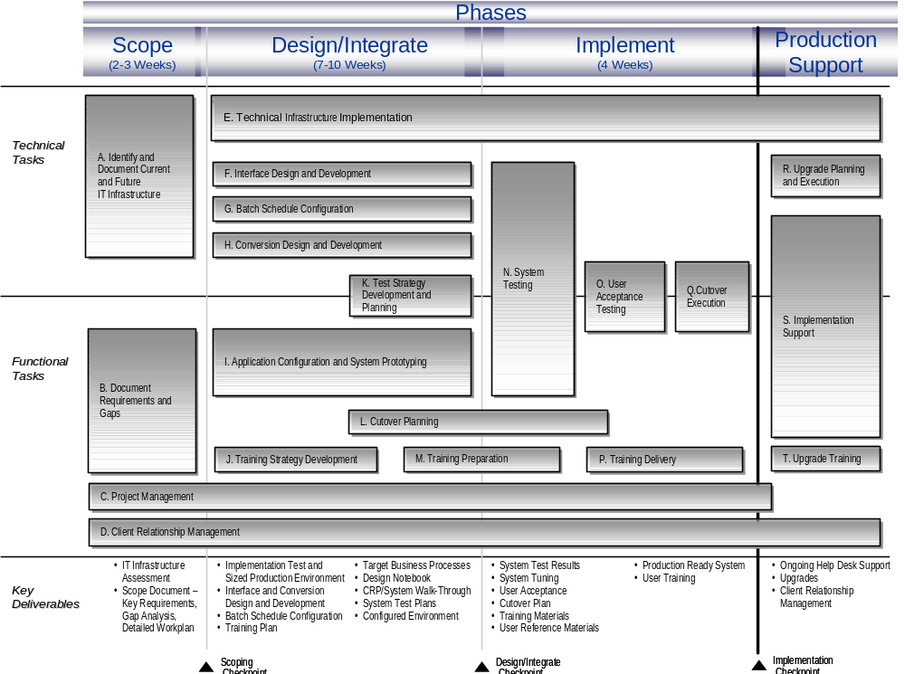

Scope Phase Overview
Scope is one of the most critical phases of the Evant’s implementation
methodology. A thoughtfully executed project scoping exercise will set a solid
foundation for the team through implementation and subsequent support. Conversely a poorly executed project scoping effort will inevitably lead to conflicts, miscommunication and frustration for all team members, both client and Evant.

Properly executing a project scope will mean working closely with the client's project management team to confirm and establish the project's approach, assumptions, and primary objectives. The core project team should identify the organization’s vision, strategy, direction, and its impact on the Evant implementation. The project scope must be defined in relation to the functional processes, Evant functionality, technical architecture, organization, interfaces, data conversion, and reports that are to be addressed during the project. Additionally, a gap analysis must be prepared to determine the variances between the legacy system and processes and the Evant Solution and related processes. As a result of this phase, an agreement should be reached with the client on the project requirements, gaps, deliverables, and work plan. A scoping document should be created to document progress, decisions, issues and next steps.

Design/Develop Overview
There is quite a bit of overlap between the design process and the development process. The process of design and development is often iterative; during the development process discoveries can be made that result in the need to quickly re-design. While ideally design should always precede development, optimum results often only occur as a result of iterative design and development.

Integrate/Implement Overview
The key objective of this phase is to ready the Evant solution for production. Activities include: system integration testing, completing cutover planning, executing conversion and cutover, and finally training delivery.

Production Support Overview
Key activities in this ongoing support phase include post implementation support and plan/execution of upgrades. During this phase transition occurs from the implementation team to customer care and the client’s IT organization.
Production Support Process:

A. Establish Technical Infrastructure
The Client Care team is responsible for provisioning a technical environment. Three environments will be created: implementation, production staging, and production. Assuming hardware and the appropriate software licenses have been procured and installed in advance, there should be little to do other than touch test application readiness for configuration.

Within Technical Infrastructure activity, an overview of the environments and how they will be managed is provided.

B. Detail Requirements & Identify System Gaps
During this activity the scoping team (inclusive of the core implementation team and internal Evant subject matter experts), will meet with key client users to look at current business processes. They will systematically review all processes that may impact the Evant implementation. The key objectives of this activity are to access the level of business fit, determine and communicate gaps to Evant, and prepare a scoping document that will include a work plan that presents how Evant will be delivered to the client.

- Prepare scoping document. At the completion of the scope phase, a scoping document should be prepared to document the decisions made. Typical agenda items include the following:
- Project Overview – objective/benefits, scope, approach, timeline
- Project Team Organization – organization structure, roles and responsibilities
- Business Architecture – high level business process model, business architecture, application scope, high level solution summary
- Technical Architecture – current technical architecture, proposed technical architecture, proposed interface design, data conversion strategy
- Next Steps – Issues/key decisions, next steps

Gaps are defined as client system requirements not supported by the base Evant solution. Issues should be documented and prioritized for level of importance to guide efforts for resolution. Having reviewed the gaps identified during the scoping phase, it is very important to communicate to Evant Product Management. Communicating gaps serves many purposes including: (a) alerting Product Management to demand for some new requirement/functionality, (b) provides project team with a sense of when gap may be included in base functionality, and (c) provides the opportunity to discuss optimal workarounds for the situation. It is preferable to present all gaps at once, but it is expected there will be times when there is a need to have multiple gap meetings if new gaps are found, or further clarification is needed.

C. Project Management
Project management requires strong communication skills that are leveraged to manage client expectations and the delivery of every task for the project duration. Key tasks are as follows:
- Implement the Evant solution meeting time and budget expectations
- Gather and document client requirements obtained through interviews, and client background research
- Prepare professional, high quality client deliverables – Project Scoping Document, System Walk-thru Document, Training Materials, etc.
- Communicate and manage work plan, tasks and schedules
- Facilitate regular project status meetings that include direct and indirect project team members.
- Follow-through with clients to ensure timely resolution of client issues
- Manage communication between client, project staff, product development, engineering, and executive management.
- Manage/oversee the implementation of the technical architecture, conversion and interfaces
- Thoroughly test our Solution prior to go-live at client site
- Advocate the use and leverage of Evant’s implementation methodology.
- Develop and continually improve our methodology through learning from current client project that can be leveraged for future clients. E.g. Project Work plans, Target Business Processes, Project Scoping Document, Systems Walk-thru Document, Design Workbook, Training Materials, Issue Logs, Gap Logs, Interface and Conversion doc., etc.
- Plan and execute cutover
- Plan upgrade process (if needed). Communicate upgrade plans with Client Relationship Manager.
- Develop solid understanding of interface design and construction, and Evant technical architecture.
- Prioritize issues, enhancements, gaps, and other lessons learned from implementation with product management

D. Client Relationship Management
Like project management, client relationship management is a highly interactive communicative process. Key tasks are as follows:
- Advocate client requirements with product management and product strategy
- Track issues related to quality of product, performance, and future functionality
- Manage contract addendums and change order procedures
- Support the authoring and development of client satisfaction surveys
- Actively encourage clients to participate in client satisfaction surveys
- Own key communication between client, project staff, product development, engineering, professional services and executive management
- Communicate work plan, tasks and schedules to client executives and senior management as applicable
- Monitor client care support for client, tracking types of issues and closure rates
- Work with Accounts Receivable on any issues surrounding a client account

E. Interface design and development
Design and development of interfaces is a very involved process and requires detailed accurate communication between functional resources and technical resources. The end goal is to build upgradeable interface programs to/from Evant and other auxiliary systems

The following are a list of typical tasks that occur during interface development:
- Code and review interface programs (following internal standards)
- Develop unit test scripts
- Conduct unit tests. Execute test scripts. Compare actual results with expected results
- Document unit test results
- Correct program errors based on unit test results
- Complete program documentation
- Develop technical documentation for client technical group

F. Conversion design and development
During this activity the data conversion strategy is defined, designed, developed, and tested. Data conversion is accomplished through manual and/or automated means and includes the creation of any data needed for new data records. It enables Evant to accurately reflect the current status of organizational data at the start of production. The term "data conversion" is used in a wider sense than the dictionary definition in that it is defined to include four separate elements:
- Purging/cleansing of existing data;
- Reconciliation/balancing of the old data and the old system/Evant;
- Creation of new/additional data; and
- Conversion of the old data to Evant to create master file data and opening balance data (where appropriate) for Evant.

G. Application design and system prototyping (including reporting)
During this activity the application is setup and prototyped with users. As the prototype process is highly interactive, it is not unusual for new requirements to surface that require the application to be setup again. A system prototyping may also be referred to as conference room pilot (CRP). The end result of the application design and system prototyping process is the agreed configuration of the Evant solution as collectively envisioned by the user community.

H. Training Strategy
It is important to document a training strategy well in advance of the go-live date. It could be brief, but it should address the following questions:
- Who is going to be trained, and in what applications/modules?
- When will training be scheduled?
- At what location will training happen? Is there an Internet connection?
- How formal/informal is appropriate?
- What is the maximum class size?
- What is the policy on users that miss a class? Do they schedule a makeover? Will they get system access before training?
- Where are the users located?
- Will there be different levels of users?
- What sorts of skills will each user level have?
- Is resistance anticipated from any user level?
- What type of tests, if any should be employed in the training process?
- What type of materials should be employed in the training process? Are they available?

I. Develop testing strategy and plans
Prior to system integration testing in the Integrate/Implement phase, a test strategy should be put together and test plans built. The following are a list of key activities that should be included in develop testing strategy and plans:
- Prepare system test strategy document. The strategy should include the following:
- System test scope – key functions of Evant that will be implemented and integrated with ancillary systems
- Key interfaces with other solutions. Identify scenarios
- Volume considerations including network throughput
- System test work plan
- Test objectives for each process
- Define test objectives. For each test objective, define the test conditions that should be tested. When all of an objective's test conditions are executed properly, the test objective should be satisfied. The types of test conditions that should be considered include valid and invalid data conditions, and system interface conditions.
- Outline system test work plan. Look at reusability of unit/system test data
- Determine system test team and responsibilities. Most likely this will be the core project team.
- Communicate with the client’s technical resources to plan availability of a dedicated and controlled system test environment. Most likely systems test will be done on the planned implementation environment (with a backup having been taken of the up-to-date application design)
- Develop system test plans. Using the test strategy as a basis, create test plans based upon client-specific scenarios, along with expected results. It may make sense to obtain some of the Evant QA team’s scripts – and leverage them to start the building of test plans. However the most important perspective the implementation team can bring to the test plans is how the client will use Evant. Referencing process maps built during Application Design and System Prototyping will also confirm that resources are being deployed most efficiently.

J. Cutover Planning
This activity straddles the Design and Integrate phases of a project implementation. The project team should keep the Client Relationship Manager in the loop on this activity. Cutover Planning ensures the transition of the system to the Users is carried out in a controlled and secured manner. It will involve thinking about various options. For example, should the cutover be ‘big-bang’, phased by site, phased by module (e.g. (MP) Merchandise Planning, (DPR) Demand Planning & Replenishment, or (EIM) Enterprise Information Management). High-level planning activities required for cutover should be documented. This will include the development of the overall approach for the cutover planning process. It is not unusual for parts of the process to be already in progress. Pieces that are in progress should be inventoried as part of the plan. For example, training may have commenced earlier if there are large numbers of staff to be trained and at a number of different locations, or data conversion preparation may have started, as it is generally a long and difficult process and may have commenced earlier in the project.

K. Training Preparation
Training preparation ensures that the transition from a test environment to a production operations environment, and the rollout to the users, is completed in a controlled and methodical manner. The implementation team should plan to leverage any material Evant Education Services have created. The final deliverable from training development is user-training material.

K1. Develop Technical Documentation
This task is necessary to successfully transition the ownership of the software from the project team to the Client Project Sponsors. The project team should ensure that the clients have adequate documentation on the new control environment.

K2. User Procedures
- User Procedures are created to guide functional and technical people in how to use, operate, or support the Evant solution. With customized training available on-line along with on-line help, functional user procedures are usually brief documents that act as quick “cheat sheets” to support the implementation learning process.
- Lastly, all user procedures should be put to the test through a ‘dry-run’ with the final user audience. The best test is always to ask someone unfamiliar with the process to perform the tasks outlined in the procedures. The team may revise the procedures, depending on the findings of the tests.

L. System integration testing
During system testing, the system test team combines all parts of the system and exercises them in varied combinations. Combinations include scenarios within Evant and between Evant and other systems. These combinations are built through incremental integration of system components, and verified through the use of test conditions and test data, which form the System Test Plan. This approach is used to ensure thorough testing of all likely business scenarios before live production.

Having prepared the testing strategy, and documented test plans, System integration testing will focus on execution. Execution will focus on normal functionality expected by the client and will also review delivery effectiveness through conducting a stress test which may lead to the need for some system tuning.

M. Training Delivery
While having the Evant solution fully tested and ready to go is critical, no less critical is the key activity of training delivery. Prior to delivery, the proper training material has been created, logistics have been sorted, and trainees have been identified and scheduled. Clear effective communication is important during training delivery, but perhaps a surprising critical success factor may be successful change management. Why change management? It is expected our clients are not interested in investing in excessive resources to re-engineer their business, but at the same time are relying on the Evant solution to bring them embedded ‘best practices’. It is expected the client team will not be seeing or hearing most of the functionality in the Evant solution for the first time and training delivery can proceed without too many issues.

N. Execute cutover
The objective of this activity is to ensure the transfer of Evant, from a test environment to a production environment, occurs in a controlled methodical and secure manner. Before cutover, the Project Manager should meet with the entire team to review for the final time the schedule, interdependences between tasks, people dependencies and any outstanding issues. The entire team should include the following: implementation consultants, client relationship manager, Evant and client technical resources, interface/conversion resources, and client team members/management as appropriate. All cutover tasks are executed during this timeframe as outlined on the detailed cutover timeline (prepared in cutover planning). As is practical, the Project Manager should mark tasks complete when they are finished successfully, and make it available, so that everyone (including client) can get an understanding of the progress being made. Each step listed on the detailed cutover timeline should be executed, without exception, especially if, as recommended, the cutover has been ‘rehearsed’ (in the “mock cutover”).

O. Plan and Execute Upgrades
Evant plans to offer production ready upgrades to the base product up to four times a year. The upgrade path will always be from the previous production version, i.e. client will not be able to do ‘double’ upgrades. Because of the rapid availability of new releases and there being no ‘double’ upgrade path, it will be very important to actively schedule upgrades. Hopefully, the upgrade process should be something that can be accomplished as part of weekend maintenance activities. However a series of communications must happen with the client to make them aware of the forthcoming upgrade and any implications it may mean. The following a preliminary list of tasks that need to be performed to manage the planning and execution of upgrades successfully:
- Client Relationship Manager (CRM) communicates date of upgrade and key additional functionality to client.
- CRM reads upgrade document and notes the following for communication to client users
- Any Decision Support reports that may need to be rebuilt (including any custom calculations)
- Any data that may be lost – e.g. saved searches, preferences
- Any menu option or look-and-feel changes
- CRM communicates and schedules additional training, or additional implementation (if needed)
- CRM communicates any change to interfaces necessitated as a result of the upgrade. Note, if this is the case, the upgrade may take longer than a weekend.

P. Implementation Support
After implementation, the core project team will need to begin relinquishing day-to-day control of the client project and transferring tasks and responsibilities to the client’s technical and user community. Ideally an Evant representative will visit the implementation site to help in the transition, but if this cannot happen, transition must happen remotely.

Q. Upgrade Training
Specific training will need to be delivered on new functionality offered to client users. Leveraging upgrade training materials created by Education Services, it is hoped the training team will not have to make too many customizations and can deliver the ‘vanilla’ version. Implementation/upgrade consultants should review tasks within the training strategy, training development, user procedures, and training delivery activities outlined in this methodology to fine-tune the delivery of any upgrade training.

Deliverables by Phase

Scope Phase Deliverables
- “As-Is” technical and business documentation
- Requirements
- Gap analysis
- Detailed work plan

- Scoping document

Design/Develop Deliverables
- Evant technical environment

- Interface and conversion
- designs and programs

- Training Plan
- Target business processes
- System test plans
- CRP/mini-system walkthrough
- Design notebook

Integrate/Implement Phase Deliverables
- System test results
- Cutover plan
- Training materials
- User procedures
- Production ready system
- User training

Evant believes that the extensive effort applied to the development of the implementation methodology will create an implementation experience that will not only meet, but exceed the requirements of Lillian Vernon. Through our proven approach we have consistently met and in many cases surpassed the return on investment that our clients anticipated receiving through Evant’s solutions. Evant was able to do this because we have a methodology that ensure that a customers business requirements are met through tools and processes that are easy to use.

Specific Resources Required
The Evant project team is usually 4-5 people: a Project Manager, Professional Services Consultant -two Business Analysts (one MP and the other DPR specific) and a Technical Analyst. The Lillian Vernon internal project team should include at least 3 people: Project Manager/Business Owner Lead, Business Analyst, and a Technical Analyst (as well as having Business and IT Sponsorship). Additionally, depending on how organization is structured other business and technical roles may be asked to participate. Throughout the implementation checkpoint meetings are scheduled to review project progress and status. A steering committee is formed inclusive of executive and business sponsorship. These meetings are held every three weeks and usually are 1-2 hours in length. During project scope activities, other business users may be asked to participate in order to fully understand current processes and activities. No more than 1-2 days of time may be required from the user community during these activities. A group of “super-users” are initially identified to validate implementation progress and work within the application during pilot activities.

- Key contact responsible for the opportunity or project
- Provide short bios on expected team members or positions used to design, implement, and provide ongoing support

  - Implementation Schedule

Attached to this document are examples of implementation plans from previous Evant installations for both the planning and replenishment modules.

  - Investment Pricing

This section should detail the following:
- Setup costs
- Consulting costs for implementation team
- Service Level Agreements
- Guarantees

  - Company Overview

At Evant, we believe that the retail industry is in an era of tremendous opportunity and significant change. Those companies that successfully build an infrastructure to support rapidly evolving business objectives will be the survivors—and the winners. At the heart of this era’s challenges is the age-old problem of having the right products, at the right place, at the right time. Evant helps retailers manage the variability in demand and supply through powerful retail management solutions that can deliver on the promise and vision of profitable retailing. By delivering our solutions on the best and most powerful technology platforms available today, Evant provides unparalleled value to our customers.

OUR MISSION
Evant’s mission is to deliver sustainable business value to our customers through advanced science, powerful solutions and next-generation technology. As a solutions provider, Evant is focused on more than delivering exceptional products and services. Our goal is to become a key long-term business partner. We provide value in the form of strategic insight, deep domain expertise and a best-practices approach to operating your business.

OUR VALUES
Our company values are centered on integrity, quality and service. We believe that a good software company is known for its products, but a great software company is also known for the way it interacts with customers, partners and employees.

COMPANY HISTORY
Evant was founded as a physical logistics company in 1994 by a team of industry experts including Stanford professor Dr. Hau Lee. Evant was launched with the goal of solving the most critical business problems faced by manufacturers, wholesale distributors and retailers in the distribution of finished goods.

As companies began to reap the benefits of new applied science in their distribution systems in the mid to late 1990s, they also began to bolster their IT infrastructures. Evant led its customer base into this new technology era by developing sophisticated forecasting and replenishment and merchandising software solutions.

Built on decades of sound logistics and distribution science, we helped our customers reduce inventory costs and raise service levels in record time. For example, in less than one year, Longs Drugs, our first software client, reduced its replenishment costs by more than 65 percent at its distribution center and more than 38 percent at its pharmacies. These improvements significantly increased cash flow, releasing more than $100 million in working capital that Longs used for other opportunities to increase earnings, including the acquisition of new chain stores.

Evant has delivered measurable business improvements similar to Longs Drugs for more than 50 Global 2000 companies. In addition to our outstanding customer track record throughout our company history, we also have remained one step ahead of the industry for nearly a decade, continually delivering the most cutting-edge demand chain science and technology applications.

I. References / Qualifications

Evant is pleased to provide Lillian Vernon with a list of references. We ask that in respect for our customers, that all contact with the companies listed below be coordinated through Amy Drevna.
Please note that the references provided below are a sample and not all of them have the same solution footprint that Lillian Vernon may want to implement. More details are below on a customer reference, Staples, that has a similar solution set as well as similar business requirements.
See attachments for additional case studies and success stories.

Evant Solution References
Company Name | Industry | Reference
- O’Reilly Automotive | Automotive Aftermarket/Retail & Wholesale | CIO
- Electronics Boutique | General/Specialty Retail | Division VP Merch. Plan’g
- HIT Entertainment | Video Production | Mgr, Retail Systems
- McQueary Brothers | Pharma/HBC Whlsl | VP Operations
- Mylan Labs | Pharma Mfr (VMI) | VP Logistics
- Portal Publications | General/Specialty Retail - Publications | Director of Purchasing
- DOT Foods | Grocery/CPG | Director of Purchasing
- Amerisource Bergen | Pharma/HBC Whlsl | VP Logistics  VP Purchasing
- Cardinal Health | Pharma/HBC Whlsl | SVP Purchasing
- Jansen Ortho McNeil | Pharma Mfr (VMI) | Assoc. Director, CPFR  Exec Director, Franch. Plan’g
- Millbrook Distribution Services | HBC, General Merch and Specialty Food Whlsl | Director Purchasing
- Kohl & Frisch | Pharma/HBC Whlsl | Executive VP

- Include a summarization of experience with similar client, project, or industry

Evant Customer Install Base
Amgen | Drugstore.com | McKesson | PVP
Anda/Andrxy Pharma | Electronics Boutique | McQueary Brothers | Richmond Masters
Autowares | Eli Lilly | Merck | Roche
Bellamy Drug | Ewing Irrigation | Millbrook | Rochester Drug Co.
Bombay | F. Dohmen | Morris & Dickson | Staples
Burlington Drug | Footlocker | Sports South Inc. | Strauss Discount Auto
Camping World | Geneva | NAPA Auto Parts | SYSCO
Cardinal Health | Good Guys | NC Mutual Drug | Teva Pharma
Cardinal NSS | HIT Entertainment | O’Reilly Auto Parts | United Building Centers
D&K Healthcare | IVAX | Party America | Value Drug Co.
Disney Auctions | Kohl & Frisch | Petsmart | Walsh
DOT Foods | Longs Drugs | Portal Publications | Watson/Schein

Lost opportunities
Blue Nile
  - Miscellaneous

Please include copies of the following:
- Contracts--copies of vendor contract or service agreement
- Documentation--copies of product information, demos, white paper, etc.
- Project methodology
- Training schedules

  - Open Ended

Lillian Vernon is working to return the company from a loss in 2002 to profitability. If you were in our shoes, what would you do first, and what would you expect the result to be? Explain in 250 words or less.
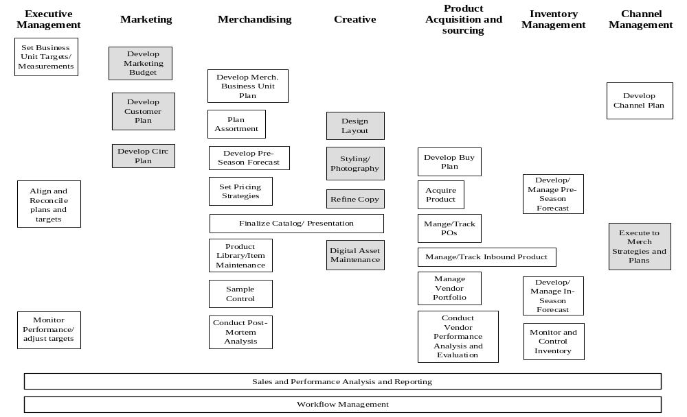

Merchandise Planning and Execution Process Overview
Designates process area in-scope
Designates process area out-of-scope
S

